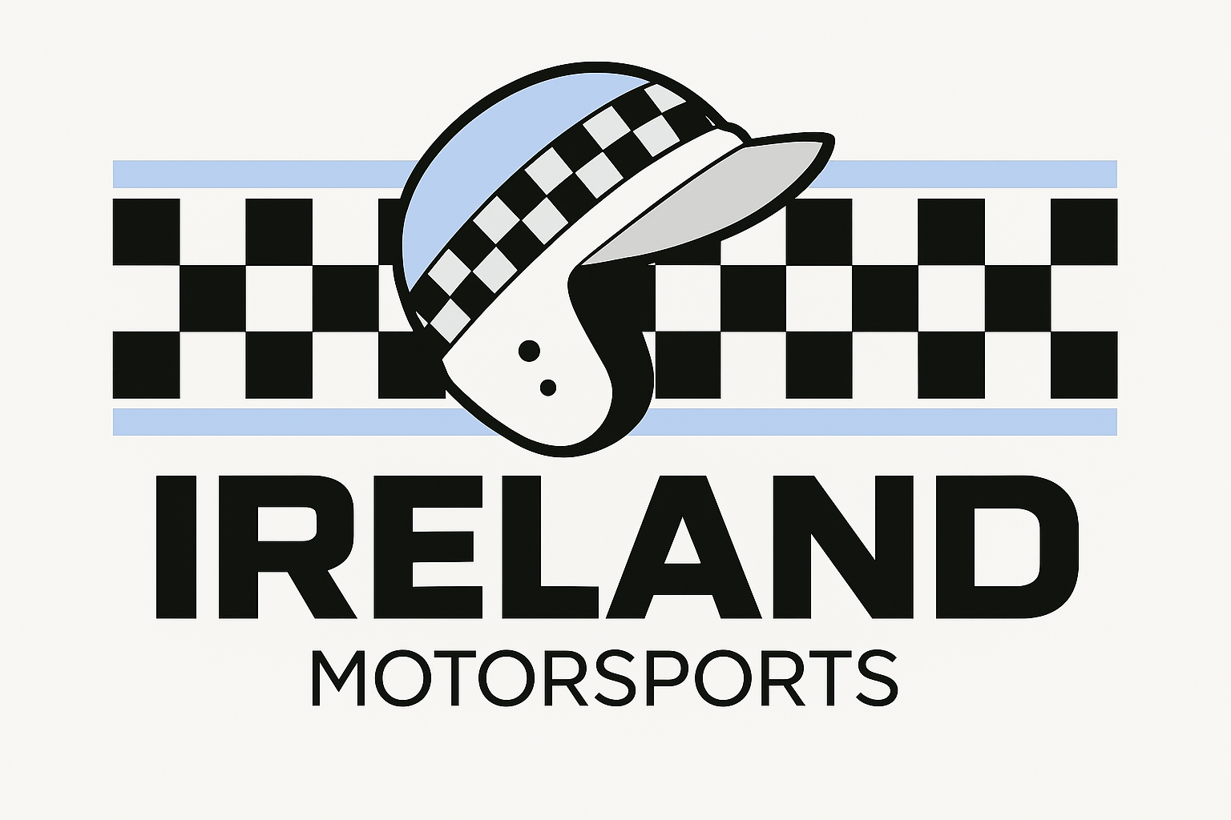

TESTIMONIAL

Name: Lennon Shea
Date of completion: November 2025

- Where are you currently working / studying?
I work at Andover Car Service and am studying at Andover college.

- How did you learn of Ireland Motorsports (‘IMS’)?
I heard of IMS through my boss at work.

- Do you feel that you could achieve your career potential at your workplace / educational establishment? Why?
No, as they are not a motorsport-oriented work place.

- Before becoming a student with Ireland Motorsports, what were your career prospects?
Becoming a motorsport technician.

- Do you feel that Ireland Motorsports fills a gap in the market for young people wanting to get into the area of motorsports? If so, how?
Yes, the connections that have become available through IMS have become invaluable to me. The hands-on experience cannot be found anywhere else.

- How would you have achieved your aims / ambitions without Ireland Motorsports?
My aims wouldn't be possible without the help of IMS.

- Have you tried to get into the area of motorsports before? If yes, what area and what was the outcome?
Yes, I contacted many teams through e-mail, but none responded to me.

- What do you hope to achieve with Ireland Motorsports?
I hope to move into formula cars or GT racing.

- How has Ireland Motorsports helped you progress on your chosen career path?
Without IMS, the aim to reach a high level racing team would be an unreachable dream. But with their help with every race weekend it looks more and more like reality.

- Do you have other aims / ambitions that you would like to further with Ireland Motorsports?
To grow with the IMS team and brand.

- How can Ireland Motorsports help with these aims / ambitions?
By continuing to provide the help they are currently giving.

- Do you have all the equipment you need to achieve these aims / ambitions? If not, what do you require?
Yes

- What have you learned with Ireland Motorsports? Are you able to transfer these skills to your chosen career path?
All of the basics from prepping the car for a race to scraping tyres. All of which are transferable to most motor racing areas.

- Do you feel supported by Ireland Motorsports?
Yes, I have been constantly supported throughout the time i have been part of IMS.

- What do you enjoy / love about Ireland Motorsports?
The friendliness and how inclusive everyone is to everyone. And how everyone feels part of a wider team.

- Would you recommend Ireland Motorsports to other young people?
Yes 100%.

- Any other comments you would like to add?
I’m looking forward to another amazing year with IMS.

End.

