FROM CLASSROOM TO PIT LANE:
HOW TO GET INTO MOTORSPORT AFTER GCSES

So, you’ve finished your GCSEs. What now? 🤔
For many students, the end of GCSEs is a crossroads. Some head straight to A-levels, others into apprenticeships - but for those with a passion for speed, engineering and teamwork, it’s also the perfect point to start steering towards a career in motorsport.
Motorsport isn’t just about drivers. Behind every car on the grid is a network of engineers, mechanics, technicians, strategists and creative minds. It needs people with a diverse skillset. So, if you’ve just finished your GCSEs, here are some of the pathways that can put you on the right track.
CHOOSING YOUR NEXT DRIVE FORWARD IN EDUCATION
After completing your GCSEs, you’ll need to decide between A-levels, vocational courses or an apprenticeship. So, what should you study next?
- A-levels: Good if you want to keep university as an option. Subjects like Physics, Maths and Design Technology are especially useful if you are keeping your options open, but with an eye to furthering your career in motorsport.
- BTECs/Diplomas in Motorsport or Engineering: These provide hands-on training and direct links to the motorsport industry and a good grounding in the motorsport world.
- Apprenticeships: A great option if you prefer to learn on the job. Apprenticeships are often run by race teams, automotive manufacturers or technical colleges in partnership with the industry.
SKILLS MOTORSPORT EMPLOYERS VALUE
Whichever path you take, focus on building skills such as:
- Mechanical knowledge (engines, suspension, electronics).
- Problem-solving and teamwork (race weekends are all about collaboration under pressure).
- IT and data analysis (modern cars generate huge amounts of information).
- Communication (clear feedback between drivers, mechanics and engineers is crucial).
REAL-WORLD EXPERIENCE MATTERS
Getting hands-on experience is just as important as academic study. Get involved:
- Volunteer at local race circuits, karting tracks or clubs.
- Join school or college motorsport programmes like the Greenpower Challenge or F1 in Schools.
- Look for weekend or part-time work in garages to build your practical skills.
- There are Specialist Pathways and Organisations across the UK (such as Motorsport UK, Silverstone UTC and ourselves, Ireland Motorsports) that focus on helping young people into motorsport. Many offer mentoring, workshops and direct career links into teams.
DON’T FORGET THE WIDER MOTORSPORT WORLD
It’s easy to think only of Formula 1, but the motorsport industry is far broader and incorporates many different areas:
- Touring cars
- Rallying
- Karting
- Endurance racing (Le Mans, GT)
- Electric racing (Formula E, Extreme E)
These areas can be more accessible starting points and can still lead to big opportunities. And remember that although motorsport needs drivers and pit crew, it also has a valued team of behind the scenes people as well:
- Event Marshalling
- Sports Photography
- Marketing
- Social Media
- Website Design
- Sports Journalism
🏁 FINAL LAP: ADVICE FOR SCHOOL LEAVERS
Motorsport is a fast-paced, competitive and demanding world, but also one of the most rewarding industries for people who love engineering, teamwork and adrenaline. If you have just finished your GCSEs, now is the perfect time to begin your career in motorsport.
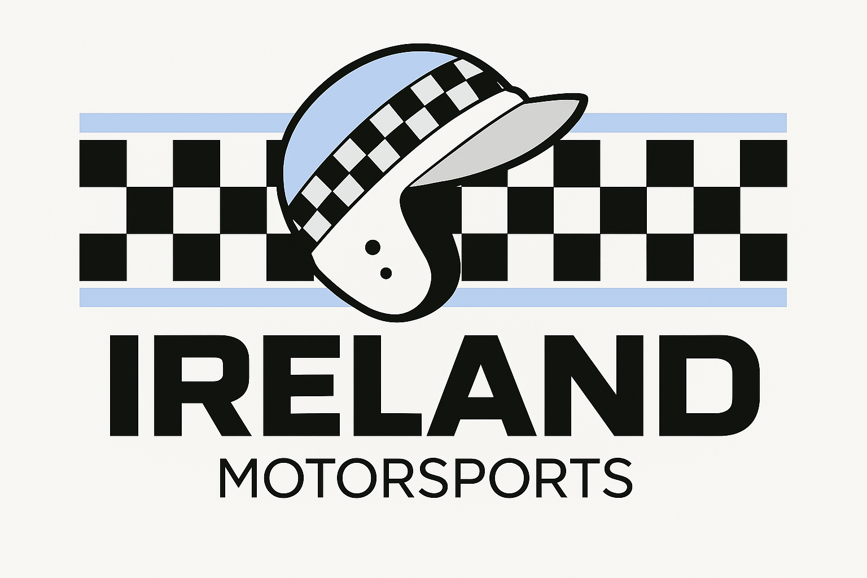
irelandmotorsports.org.uk

